Request – Response Best Practices

[Document subtitle]

**HTTP/HTTPS Request Response Communication**

* **In request/response communication mode.**
* **One software module sends a request to a second software module and waits for a response.**
* **The First software module performs the role of the client.**
* **The second, the role of the server,**
* **This is called client/server interaction.**

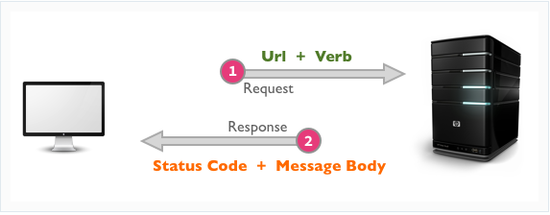

**HTTP Client**

* **Browser Level Client**
* **Application Level Client**

**Browser Level Client**

**Browser is the primary HTTP client responsible for load the web application**



**Application Level Client**

* **HTTP Client is an application library used in client side application to generate request and receive response.**
* **HTTP Client’s libraries varies from platform to platform**

|  |  |  |
| --- | --- | --- |
| **HTTP Client Library** | **Platform** | **Language** |
| Volly | Native Android | Java |
| Retrofit | Native Android | Java |
| Rest Sharp | ASP.NET | C# |
| Axios | Mobile/Web/Desktop | JavaScript |
| cURL | Web | PHP |
| Alamofire | Native IOS | Swift |

**POSTMAN Http Client**

Postman is an HTTP Client application, used to test request-response communication. Postman is widely used for API testing and generating documentation.

* **Quickly and easily send REST, SOAP, and GraphQL requests directly within Postman.**
* **Generate and publish beautiful, machine-readable API documentation.**
* **Checking performance and response times at scheduled intervals.**
* **Communicate the expected behavior of an API by simulating endpoints and their responses**

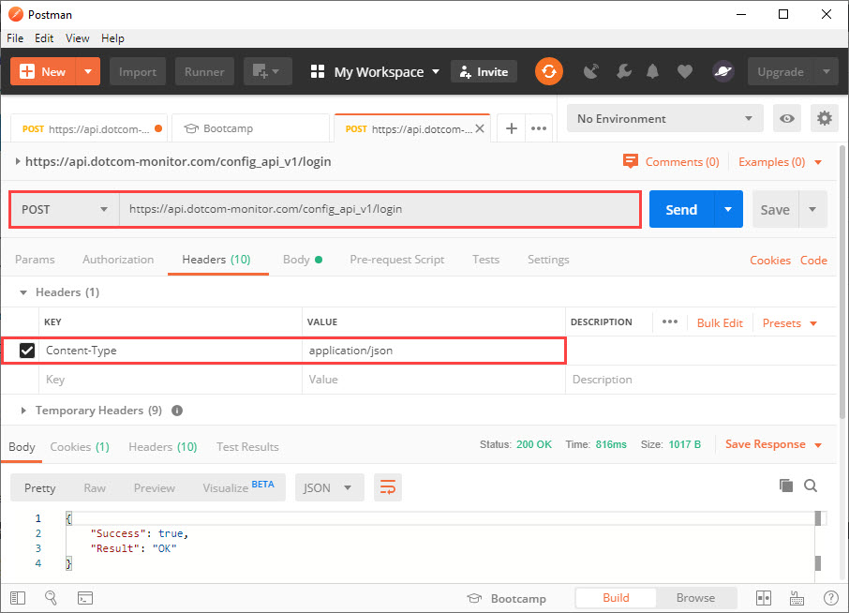

**HTTP Request**

HTTP Request is the first step to initiate web request/response communication. Every request is a combination of request header, body and request URL.

**Http Request Segments:**

|  |  |
| --- | --- |
| Request Area | Standard Data Type |
| Body | Simple String, JSON, Download, Redirect, XML |
| Header | Key Pair Value |
| URL Parameter | String |

**HTTP Request Methods**

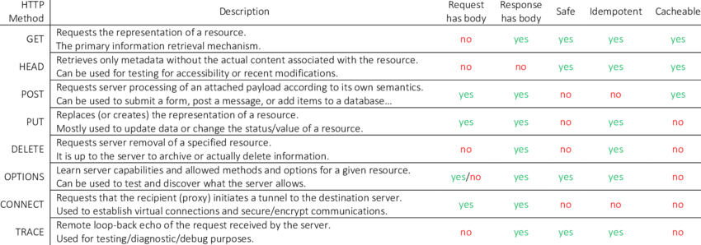

**Request Compare GET vs. POST**

|  |  |  |
| --- | --- | --- |
| **Key Points** | **GET** | **POST** |
| BACK button/Reload | Harmless | Data will be re-submitted (the browser should alert the user that the data are about to be re-submitted) |
| Bookmarked | Can be bookmarked | Cannot be bookmarked |
| Cached | Can be cached | Not cached |
| Encoding type | application/x-www-form-urlencoded | application/x-www-form-urlencoded or multipart/form-data. Use multipart encoding for binary data |
| History | Parameters remain in browser history | Parameters are not saved in browser history |
| Restrictions on data length | Yes, when sending data, the GET method adds the data to the URL; and the length of a URL is limited (maximum URL length is 2048 characters) | No restrictions |
| Restrictions on data type | Only ASCII characters allowed | No restrictions. Binary data is also allowed |
| Security | GET is less secure compared to POST because data sent is part of the UR  Never use GET when sending passwords or other sensitive information! | POST is a little safer than GET because the parameters are not stored in browser history or in web server logs |
| Visibility | Data is visible to everyone in the URL | Data is not displayed in the URL |

**Http Request Throttling**

Throttle Request refers to a process in which a user is allowed to hit the application maximum time in per second or per minute. Throttling is also known as request rate limiting.

* Essential component of Internet security, as DoS attacks can tank a server with unlimited requests.
* Rate limiting also helps make your API scalable by avoid unexpected spikes in traffic, causing severe lag time.

**HTTP Response**

Http response is the final step of request-response communication. Every response is a combination of response header, body an d cookies.

**Http Response Segments:**

|  |  |
| --- | --- |
| Response Area | Standard Data Type |
| Body | Simple String, JSON, Download, Redirect, XML |
| Header | Key Pair Value |
| Cookies | Key Pair Value |

**HTTP Response status messages**

***1xx: Information :***

|  |  |  |
| --- | --- | --- |
| **Code: Message:** | **Description:** | |
| 100 Continue | | The server has received the request headers, and the client should proceed to send the request body |
| 101 Switching Protocols | | The requester has asked the server to switch protocols |
| 103 Early Hints | | Used with the Link header to allow the browser to start preloading resources while the server prepares a response |

***2xx: Successful :***

|  |  |
| --- | --- |
| **Code: Message:** | **Description:** |
| 200 OK | The request is OK (this is the standard response for successful HTTP requests) |
| 201 Created | The request has been fulfilled, and a new resource is created |
| 202 Accepted | The request has been accepted for processing, but the processing has not been completed |
| 203 Non-Authoritative Information | The request has been successfully processed, but is returning information that may be from another source |
| 204 No Content | The request has been successfully processed, but is not returning any content |
| 205 Reset Content | The request has been successfully processed, but is not returning any content, and requires that the requester reset the document view |
| 206 Partial Content | The server is delivering only part of the resource due to a range header sent by the client |

***3xx: Redirection :***

|  |  |
| --- | --- |
| **Code: Message:** | **Description:** |
| 300 Multiple Choices | A link list. The user can select a link and go to that location. Maximum five addresses |
| 301 Moved Permanently | The requested page has moved to a new URL |
| 302 Found | The requested page has moved temporarily to a new URL |
| 303 See Other | The requested page can be found under a different URL |
| 304 Not Modified | Indicates the requested page has not been modified since last requested |
| 307 Temporary Redirect | The requested page has moved temporarily to a new URL |
| 308 Permanent Redirect | The requested page has moved permanently to a new URL |

***4xx: Client Error :***

|  |  |
| --- | --- |
| **Code: Message:** | **Description:** |
| 400  Bad Request | The request cannot be fulfilled due to bad syntax |
| 401 Unauthorized | The request was a legal request, but the server is refusing to respond to it. For use when authentication is possible but has failed or not yet been provided |
| 402 Payment Required | *Reserved for future use* |
| 403 Forbidden | The request was a legal request, but the server is refusing to respond to it |
| 404 Not Found | The requested page could not be found but may be available again in the future |
| 405 Method Not Allowed | A request was made of a page using a request method not supported by that page |
| 406 Not Acceptable | The server can only generate a response that is not accepted by the client |
| 407 Proxy Authentication  Required | The client must first authenticate itself with the proxy |
| 408 Request Timeout | The server timed out waiting for the request |
| 409 Conflict | The request could not be completed because of a conflict in the request |
| 410 Gone | The requested page is no longer available |
| 411 Length Required | The "Content-Length" is not defined. The server will not accept the request without it |
| 412 Precondition Failed | The precondition given in the request evaluated to false by the server |
| 413 Request Too Large | The server will not accept the request, because the request entity is too large |
| 414 Request-URI Too Long | The server will not accept the request, because the URI is too long. Occurs when you convert a POST request to a GET request with a long query information |
| 415 Unsupported Media Type | The server will not accept the request, because the media type is not supported |
| 416  Range Not Satisfiable | The client has asked for a portion of the file, but the server cannot supply that portion |
| 417 Expectation Failed | The server cannot meet the requirements of the Expect request-header field |

***5xx: Server Error :***

|  |  |  |
| --- | --- | --- |
| **Code: Message:** | | **Description:** |
| 500  Internal Server Error | A generic error message, given when no more specific message is suitable | |
| 501 Not Implemented | The server either does not recognize the request method, or it lacks the ability to fulfill the request | |
| 502 Bad Gateway | The server was acting as a gateway or proxy and received an invalid response from the upstream server | |
| 503 Service Unavailable | The server is currently unavailable (overloaded or down) | |
| 504 Gateway Timeout | The server was acting as a gateway or proxy and did not receive a timely response from the upstream server | |
| 505 HTTP Version Not  Supported | The server does not support the HTTP protocol version used in the request | |
| 511 Network Authentication  Required | The client needs to authenticate to gain network access | |